1. Spine-leaf architecture is a two-layer network topology, commonly used in data centers, consisting of leaf switches that connect to servers and spine switches that interconnect all leaf switches in a full-mesh topology, improving scalability and reducing latency.

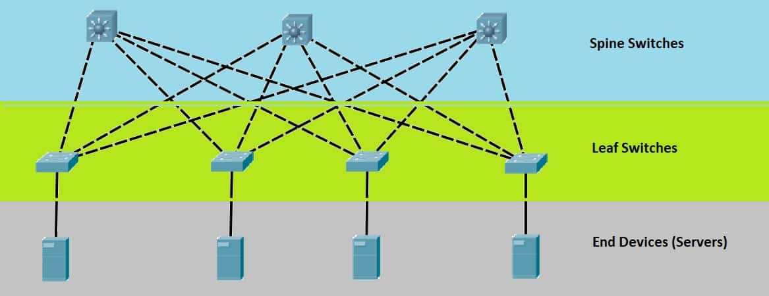

1. What are PCIe and RDMA, and how are they used in computer systems?

PCIe: A high-speed serial expansion bus standard that connects the motherboard with high-performance hardware devices.

RDMA: A technology that allows one computer to directly access the memory of another without involving the remote CPU or operating system.

1. Function as a Service (FaaS): Write apps using cloud functions, triggered by events. Example: AWS Lambda.

Machine Learning as a Service (MLaaS): Pipelines & tools for training and deploying models. Model APIs like ChatGPT (pre-trained and accessible via API).

1. Issues of cloud: availability.

Cloud services must be accessible at all times. Downtime in cloud infrastructure can affect entire organizations.

1. Cloud computing is a model for delivering computing services—such as servers, storage, databases, networking, software, analytics, and artificial intelligence—over the internet ("the cloud") on demand.